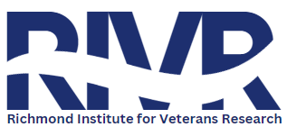
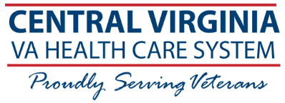
Research
Opportunity

NASA MRI BONE STUDY
Category: Spinal Cord Injury/Radiology
Description: This study aims to determine if a new magnetic resonance imaging (MRI) technique can accurately monitor bone loss. It will compare the MRI against other scanning techniques. This study is funded by National Aeronautics and Space Administration (NASA).
Study Duration: Total of 1-2 visits. Participants with spinal cord injury will complete (2) visits over the span of (1) year. Healthy control participants will complete (1) visit lasting approximately 4 hours.
Who can participate?
You may be eligible to participate in this study if you:
- Are 18-65 years of age
- Fit into one of the two categories below:
  - Have sustained a spinal cord injury (SCI) in the past 2.5 years
    - SCI must be due to trauma/force (ex: car accident, fall, sports, etc.)
    - Must be either AIS A, B, or C
  - Have no major health issues (contact the study team if you are unsure if you qualify)
Note: Each study has its own eligibility requirements. A screening will determine if you qualify.
What is Involved?
Time Commitment: 4 hours per visit (can be broken into multiple days or done all at once). For participants with spinal cord injury, a total of 2 visits is required. For controls, only 1 visit is required.

Participation may include:
- Lab tests (blood)
- Screening of medical history
- MRI scan of bones in hip and ankle.
- Dual-energy X-ray absorptiometry (DXA) scan of bones in hips, knees, and spine.
- High-Resolution Peripheral Quantitative Computed Tomography (HRpQCT) scan of wrist & ankle.
Compensation: $200 per visit
Contact: Name: Emily Moran Phone: 804-933-3923

Investigator: Robert Adler, MD IRB of Record: Richmond VA IRB
IRBNET #: 1773410
IRB Approval Date: 03/03/2026
Version 2: Dated 10/21/2025

