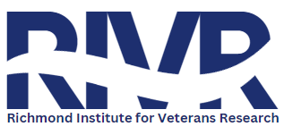
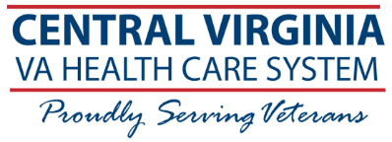
Research
Opportunity

Testing a Novel Dry Electrode Headset for Electroencephalography Telehealth
Category: EEG (brain wave study)
Description: The purpose of this study is to test a new way of recording EEG using an EEG device made by a company called Zeto, Inc. This device has been cleared for use by the Food and Drug Administration. This study is designed to find out if the Zeto EEG is as well tolerated and accurate at detecting signs of epilepsy as a standard EEG.
Study Duration: Participation in the study will take one 3-hour study visit to the Neurology EEG Clinic.
Who can participate?
You may be eligible to participate in this study if you:
- Have an appointment for an EEG already scheduled to be performed in the Neurology EEG Clinic at CVHCS.
- Have had a previous EEG that showed a risk for seizures.
Note: Each study has its own eligibility requirements. A screening visit or phone call will determine if you qualify.

What is Involved?
Time Commitment: One study visit to the Neurology EEG clinic, lasting approximately 3 hours.

Participation may include:
- EEG recording data being shared with study investigators at the three VA research sites (Richmond, Miami, and Charleston)
- Go without sleep the night before the EEG
- Questionnaires, consent and surveys
- One Zeto EEG and one standard EEG, both recorded during the same visit
Compensation: $60/visit
Contact: Name: Nicole Coleman
Phone: 804-675-5000 Ext: 13743

Investigator: Waterhouse, Elizabeth MD IRB of Record: Richmond IRB
IRBNET #: 1658802
IRB Approval Date: 01/29/2026
Version 2: Dated 10/21/2025

